Steven Kim

Mr. Mason

ADV Cisco CCNP P 1, 2

1/22/14

Partner: Matthew Zhao

Lab 6 Part 1: VOIP Basics (Connection)

**Purpose**

The purpose of this lab is to establish connectivity between two phones using Voice Over IP (VOIP), a skill that is essential in small enterprises or companies.

**Background Information on lab concepts**

Cisco Unified Communications Manager (CUCM): A calling system designed to manage all

All configurations are done through a web interface (supported browsers: Firefox and Internet Explorer). This system was the basis of our lab, due to its ability to manage and help us configure phones and gateways. A possible parallel to the relationship between CUCM and this lab would be that of CPU and a computer: CUCM acts as the central bridge that monitors and manages phone connectivity. CUCM is also Cisco proprietary, meaning that only Cisco devices, including phones, can be managed using this system.

Voice Over IP (VOIP): A protocol that is responsible for transferring voice communications over Internet Protocol (IP) networks. VOIP is commonly used in almost every part of communication between one to another, from connection between phone to phone in the same, wired network to the connection between wireless phones. Examples include H.323, Skype protocol, and Real-time transfer Protocol (RTP)

* Another name for VOIP is Internet Telephony. This term indicates communication over public Internet such as fax, SMS, and voice-messaging.

VMWare Workstation 8: A virtual software that allows virtualization of a server without an additional operational system. VMware simulates the CPU of a computer and maximizes the efficiency of simulation. It is crucial that VMware be set up before setting up CUCM, for its virtualization allows an effect simulation.

Dynamic Host Control Protocol (DHCP): A networking protocol that automatically (dynamically) assigns IP addresses to devices in the same network as the server. DHCP removes the inconvenience of having to statically configure different IP addresses, especially when it comes to assigning IP addresses to IP phones.

Network Time Protocol (NTP): A networking protocol for synchronizing devices in the same network. NTP provides updates in a peer-to-peer network.

**Lab Summary**

There are essentially 4 parts to this lab: Setting up VMWare, installing CUCM, setting up CUCM, and configuring CUCM.

VMWare Installation

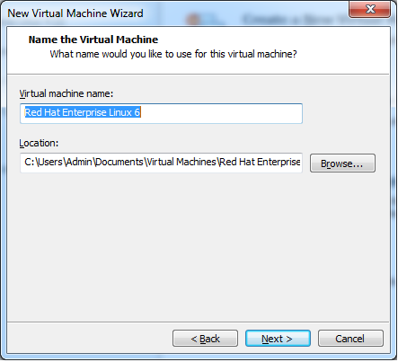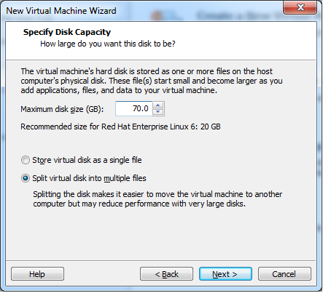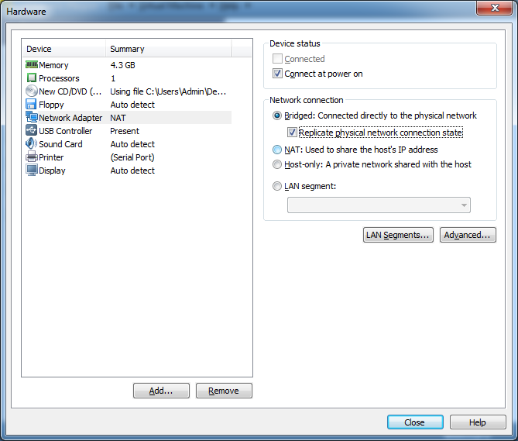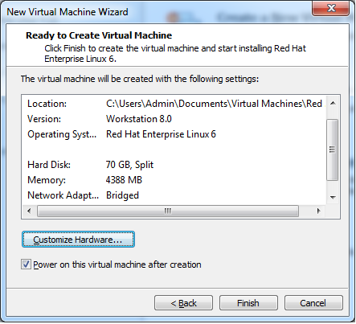

<From left to right, top to bottom>

Select Red Hat Enterprise Linux 6.

Make sure that the maximum disk capacity is at least 70.0GB.

Select “Bridged: Connected directly to the physical network” and click close.

After making sure that the three steps above have been implemented, click Finish. A blue installation screen will appear.

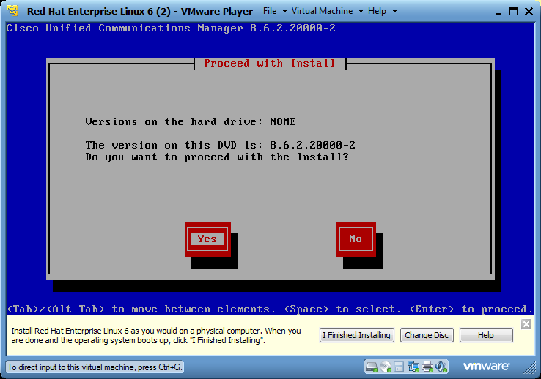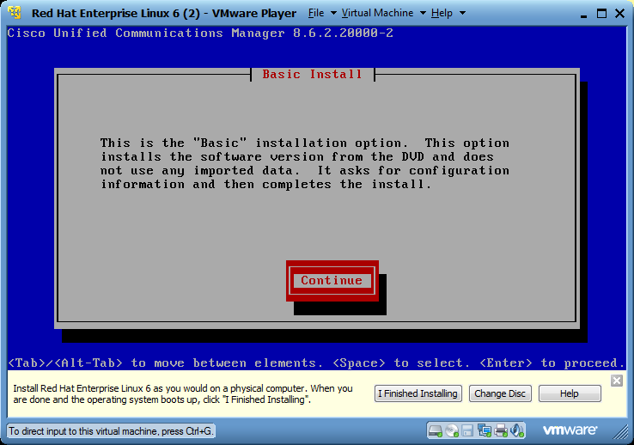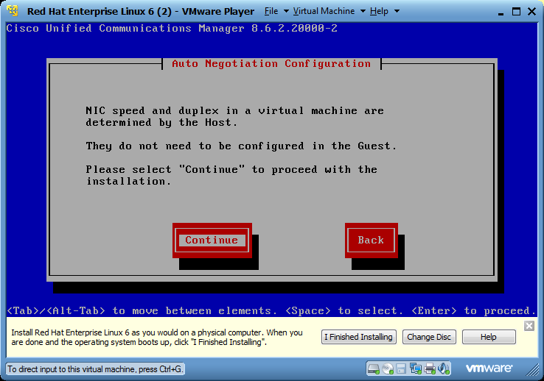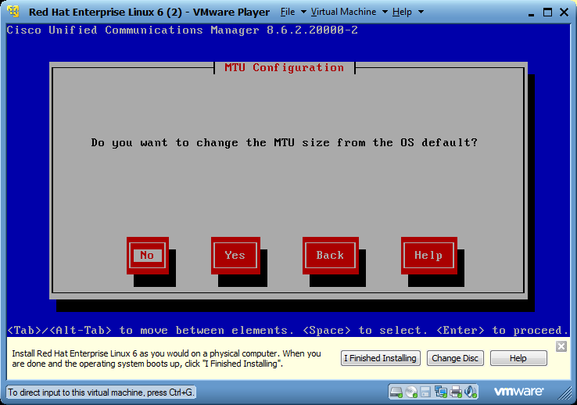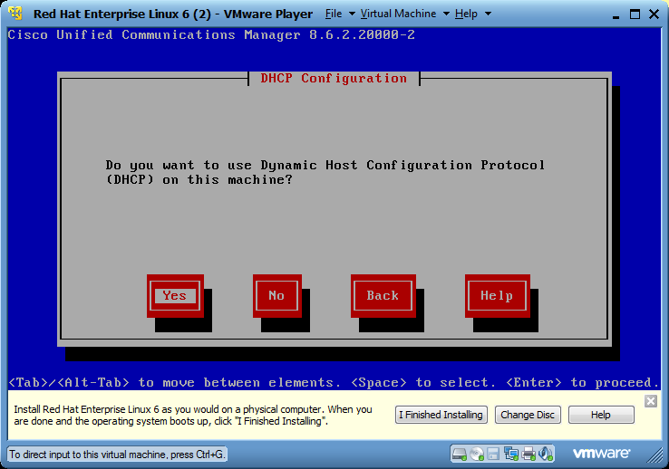

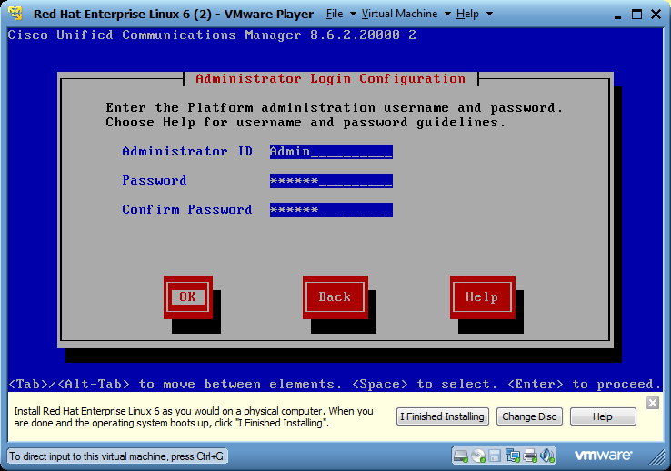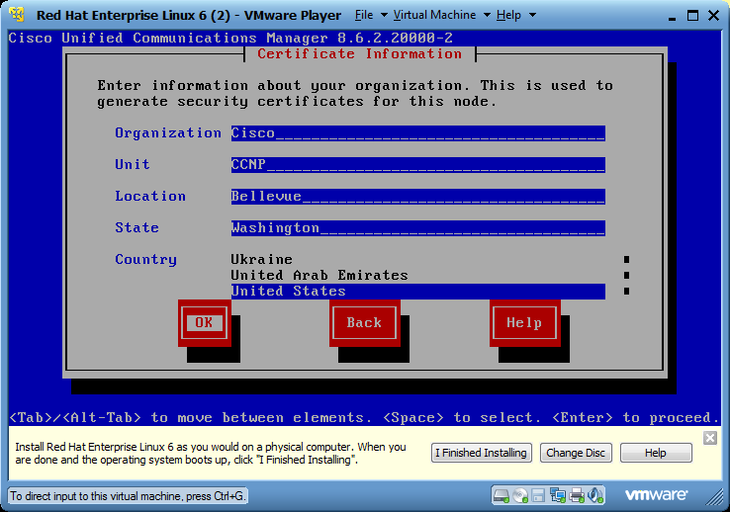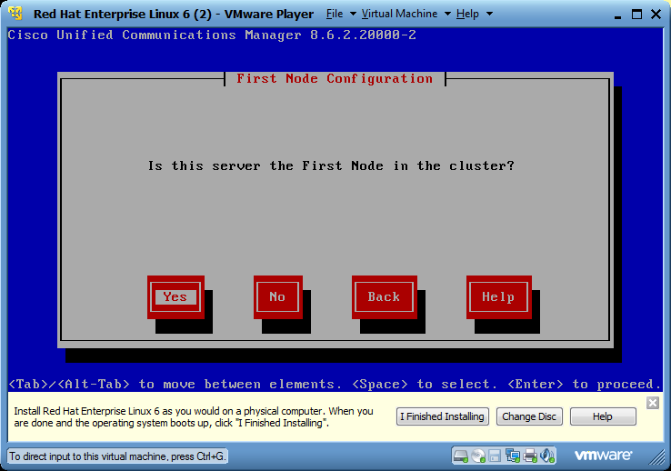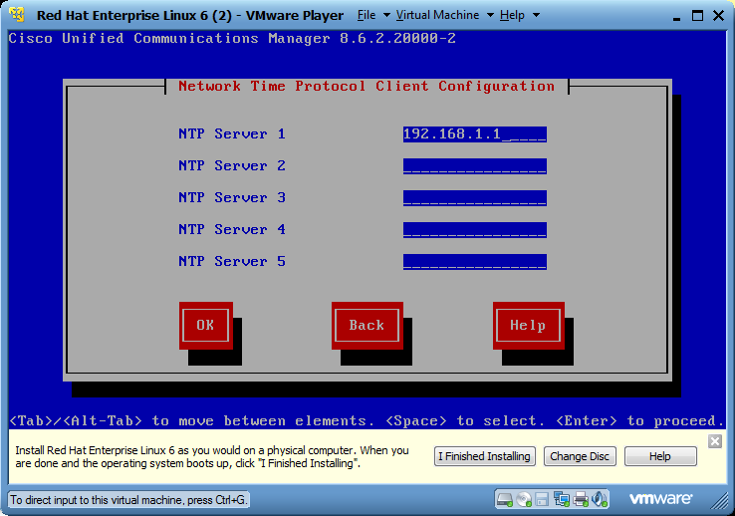

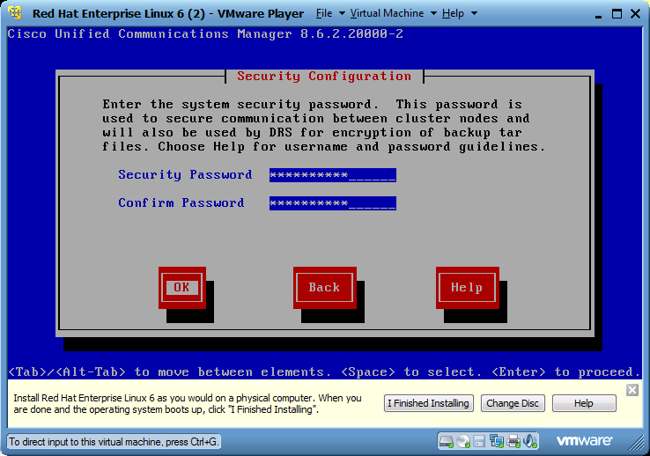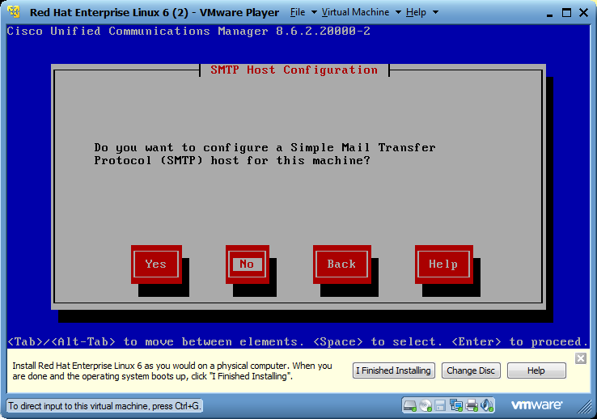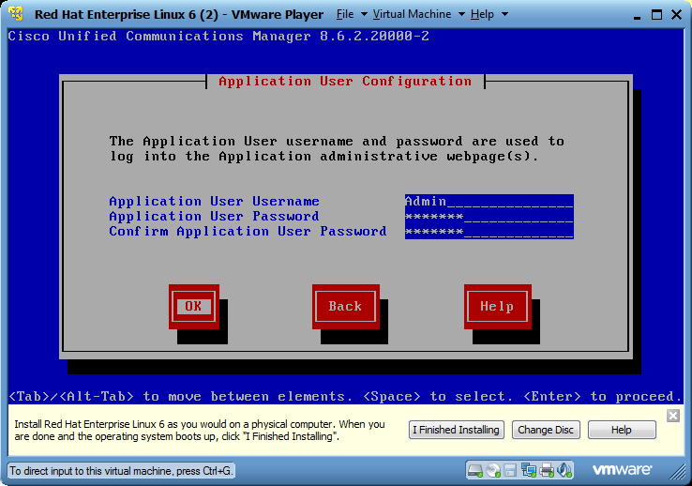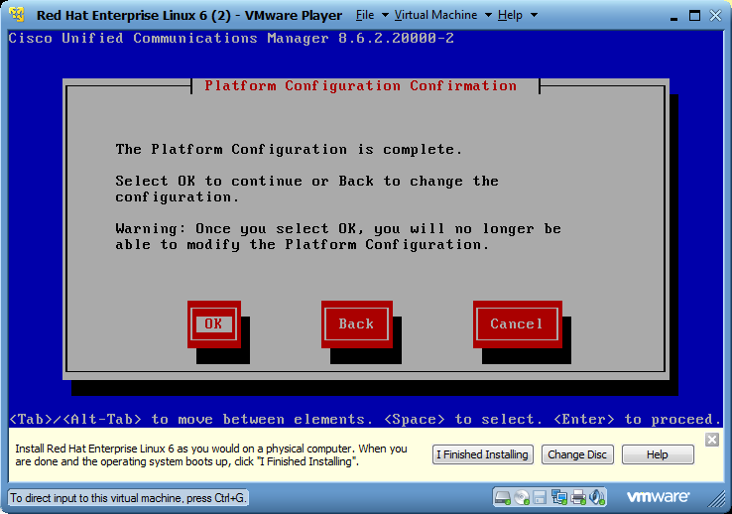

For every step, click the highlighted option (options that are marked with a white box)

<From Top to bottom, left to right>

Start installation.

Do not change the MTU size from the default.

Select the option Yes for configuring DHCP.

Enter the administrative username and password.

Select Yes for the question regarding the First Node Cluster.

Enter the IP address of the NTP Server (in this case, the router).

Create an administrative password consisting of capital and lowercase letters, symbols, and numbers.

Select No for the question regarding SMTP. SMTP is not needed for this lab.

Set the application username and password.

Click Ok. A blue installation screen will appear.

CUCM Setup

**Lab Commands**

Commands for configuring DHCP

|  |  |
| --- | --- |
| ip dhcp excluded-address | Avoids conflict with any statically assigned IP addresses |
| ip dhcp pool Voip | Enters DHCP Configuration Mode |
| network [network-address] [prefix] | Configures network address of DHCP |
| default-router [ip address of the router] | Configures default router (exit interface) |
| dns-server [ip address of the dns server] | Configures DNS server |
| domain-name [name] | Configures domain name |
| option 150 ip [ip address of the DHCP server] | Binds the TFTP server to the DHCP server |
| ntp master | Establishes Router as Central NTP |
| ntp server [ip address of the TFTP server] | Establishes the TFTP as an NTP server |

**Network Diagram with IP’s**

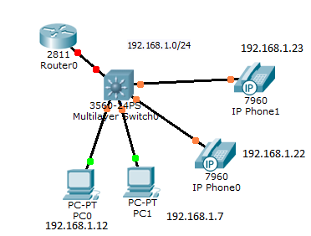

**Configurations**

Show run on R1

hostname R1  
!  
memory-size iomem 10  
clock timezone PST -8  
no network-clock-participate slot 1  
!  
no ip dhcp use vrf connected  
ip dhcp excluded-address 192.168.1.1  
ip dhcp excluded-address 192.168.1.5  
ip dhcp excluded-address 192.168.1.6  
!  
ip dhcp pool Voip  
 network 192.168.1.0 255.255.255.0  
 dns-server 192.168.1.1  
 default-router 192.168.1.1  
 domain-name Voip  
 option 150 ip 192.168.1.6  
!  
ip domain name Voip  
ip name-server 192.168.1.1  
!  
voice-card 0  
 no dspfarm  
!  
voice-card 1  
 no dspfarm  
!  
voice service voip  
 allow-connections h323 to h323  
 h323  
!  
voice class h323 1  
 h225 timeout tcp establish 3  
!  
interface FastEthernet0/1  
 ip address 192.168.1.1 255.255.255.0  
 duplex auto  
 speed auto  
 h323-gateway voip bind srcaddr 192.168.1.1  
!  
ip classless  
!  
voice-port 0/3/0  
!  
voice-port 0/3/1  
!  
voice-port 0/3/2  
!  
voice-port 0/3/3  
!  
voice-port 1/0/0  
!  
voice-port 1/0/1  
!  
dial-peer voice 10 pots  
 destination-pattern 9...........  
 port 0/3/0  
 forward-digits all  
!  
scheduler allocate 20000 1000  
ntp broadcastdelay 10  
ntp source FastEthernet0/0  
ntp master 4  
ntp update-calendar  
ntp server 192.168.1.1  
!  
end

**Problem**

The main problem that I encountered during this lab was managing CUCM. CUCM is a system that I have never encountered before when I was a CCNA. Initially I did not know what each of the categories in the top right corner – Cisco Unified Serviceability, Cisco Unified Reporting, Disaster Recovery System, Cisco Unified Serviceability, and Cisco Unified OS Administration. Therefore, I had to research every one of these categories and figured out what each category did. The worst part was having to recognize them and think about how I could use each category to establish connection between the two IP phones.  
 Also, the overall installation process was somewhat confusing. I did not know what an NTP server, a first node, nor a MTU size, thinking that installation is a simple process. Therefore, I had to go through extensive research to gain both the spec and the general picture of the lab. I realized one thing: background knowledge is crucial to performing a lab before starting it.

**Conclusion**

Overall, I managed how to establish connection between two IP phones using VOIP, for I was able to call one phone from another. Although I had some trouble figuring out how to install and manage CUCM, the overall lab was not difficult. I learned how to configure a phone - a skill that is crucial to enterprises and companies.